Our project name is **Men of Mosque**. In this world, everywhere has mosque. In this mosque there has a imam and muazzin. Our software will help to recruit imam and muazzin in mosque.

**1.1 Background problem:**

Suppose a mosque need a imam or muazzin. Usually through recruitment notification, we try to find better imam or muazzin. it’s a very long and time consuming process. Because by through recruitment notification first we collect some candidate and then we sort out from the candidate for better our mosque. Besides many of candidate who wants to be a imam or muazzin can’t get the recruitment notification in time. Even by through recruitment notification sometime we can’t get proper imam or muazzin for the mosque. Sometimes we can’t hire proper imam or muazzin in the time by through recruitment notification.

**1.2 Solution:**

Our software can solve all this problem. Our software will provide the imam and muazzin. Those who need imam or muazzin to the mosque, they don’t need to through any recruitment notification. Because in our software there will be an available candidate and those who need they can get many candidates with their bio and they can recruit by their own choice. This software will also help those candidate who wants to be a imam or muazzin. Candidate has to wait for recruitment notification those mosque need imam or muazzin. Sometimes they can’t get all the requirement notification. But if they use this software they can easily update which mosque give requirement notification. This software also save time for both candidate and those who want imam or muazzin.

**Software system:**

When a user use this software they have to sign up and there will be two option. One is applicant and another is recruitment. In applicant option candidate can make their own profile and apply for imam or muazzin. In our software there will have database. In this database all the information will save of the candidate who want to be a imam or muazzin. There will be a notification bell system which shows which mosque need imam or mosque to the candidate. Candidate can apply those recruitment post via notification bell.

There will another option name recruitment which allow user that post a recruitment for imam or muazzin. When user post a recruitment of imam or muazzin of that post candidate will response his post and user can show all the information of candidate which candidate upload on his profile. If user choose a candidate they can also communicate with the candidate. There will be another option name interview, which allow the user can take a interview with the candidate via video and audio.

**2.1 Process Model:**

First of all our project environment is predictive. Because we will have all the clear details about our project that we already mentioned in the software system (1.2). There will have no change to the original software system functionality. We have a clear understanding what we are going to develop. Secondly, our software is not only for particular that customer or client.

We are going to use waterfall model which is a linear sequential model for our project. There are various reasons to use this waterfall model for our project. Such as, our project environment is predictive but if we use agile model for our project it will not helpful for us. Because agile model project environment is adaptive. For this reason we have to more give time to the agile model. But if we use waterfall model we don’t have to give extra time for planning or understanding. Because our project environment is predictive and we all have all the clear details about our project. As we know what things to develop. So, we don’t have to separate the work. we can easily done our development by sequentially. This is called linear sequential development which support waterfall model. Waterfall model is very appropriate for safety critical product. Waterfall model is very simple to understand and easy to use because of its systematic well-defined process description. The product is delivered to the users at ONE shoot. The main thing is our environment is stable, we have all well understood requirements then we don’t need to separate that woks. We don’t have any particular client that we have to describe them of all things that we have done. We don’t need to use like V-model, SAW-TOOTH model. In V-model and SAW-TOOTH model we have to take client or customer feedback. But in our project we don’t need to take feedback from anyone because we have clearly know what have to do. We just develop the project at linear sequentially and delivered to the users at ONE shoot. Our software is for all. And that’s why we are going use waterfall model.

## Project Role Identification and Responsibilities:

As we mentioned to the previous in 2.1(Process Model) that for our project we are going to use waterfall model. In this model there are five phases. Each of the phases do different kind of role. Here we are describing which phase has done which part.

1)**Communication:** In this phase, there have two roles. One is project initiation, and another is requirements gathering. This communication phase tries to familiar us with our project and collects all the requirements for develop this project.

2)**Planning:** In this phase there have three kinds of activities. The first one is estimating. The secondly is scheduling, and the last one is tracking. Mainly this phase role is project management. It means what will be the budget for this project, what materials will need, how many human resources will need, how much time will need to develop this project. This activity will do in this planning phase.

3)**Modeling:** There are two roles in this phase. From begin will analyse this project (depending on the communication and planning phase). After finishing the project analysis now will do the design for this project (like a diagram, moc design etc.).

4)**Construction:** Mainly in this phase, the project will take shape in reality. Because in this phase will do code based on design (Modeling phase). After doing the code, the last role in this phase is testing. If there are any bugs or issues will try to find out by testing in this phase.

5)**Deployment:** This is the last phase of this waterfall model. In this phase, there have three activities. The first one is after the complete construction phase; this phase will deliver to the customers. The second role is supported. It means after delivering the project to the customers, if there is any issue on the project (like database issue, UI issue or something else), this phase will support. And the last one is to take feedback from the customers or clients.

Now the question is, what is so unique about the waterfall model. The answer is that these model phases are connected distinctly. It means each step will move forward to the subsequent stages until finishing before stage 100%.

## 3.1-System Features:

# Software Sign up:

**Functional Requirements-**

* 1. Before use this software, first user shall have to give their some information to sign up on this software.
  2. The software shall have a own secure database. In this database the information that given users will be save and it will analyses when user try to login in this software.
  3. In this software there has two category that user shall have to select before sign up. One is applicant and another is recruitment.

**Priority Level:** High

**Precondition:** User have to select one category

**Cross-references:** Null

# Software User interface (UI):

**Functional Requirements-**

* 1. The software UI shall have to be simple or user-friendly that user can operate this software very easily.
  2. As this software is for two category user, it shall have to two different kind of UI.
  3. For category ‘applicant’, this software shall allow the user to see the recruitment post and shall allow to easily comment on this post.
  4. For category ‘requirement’, this software shall allow the user to post for what user need and also can read comment for their post.

**Priority Level:** High

**Precondition:** Null

**Cross-references:** Null

# Software Communication:

**Functional Requirements-**

* 1. This software shall allow communication features between the users.
  2. There have three kind of communication feature in this software. First one audio. Second one video and last one messaging.
  3. Both of the category users can communicate themselves via audio, video or messaging which they want.

**Priority Level:** High

**Precondition:** Null

**Cross-references:** Null

## 3.2-System Quality Attributes:

There are two types of perspective of quality attributes

First one is user perspective. There are 8 important primarily quality attributes to user perspective.

**I)Availability:** The system shall be at least 98.5 percent available on every seven days a week between 12.00 am to 11.59 pm at local time.

**ii) Efficiency:** There are at least 3.5 percent of the processor capacity, disk space 1.7 MB/S , memory 120MB and communication bandwidth 512kbps shall be available to properly run this system .

**iii) Flexibility:** A maintenance programmer who has at least 8 months of experience shall be able to add new feature and function including code, modifications and testing into the system with no more than three hours.

**iv) Integrity:** When user try to login into the system, there shall have to two step verification. One step is while user try to login into the system, the system will send a verification code to the user via mail and user shall have to use that verification code to login and the second step is user shall have to use their own password while they create the password to sign up this system.

**v) Interoperability:** When a user sign-up to the system the user has to give some their general information like photo, NID to the system. So, system need to justify the information whether the user given information. For that reason, the system shall be able to import valid information which shall have matched to the user given information. The system shall import the information from local election commission office.

**vi) Reliability:** The system shall no more than three experimental runs out of 800 can be lost.

**vii) Robustness:** In the system there are two kind of users. One is applicant and another is recruitment. If the recruitment fails to edit their post before the applicant saves the post, the recruitment shall be able to recover all changes made in the post being edited and shall be able to that edited post within 20 seconds.

**viii) Usability:** When the recruitment do post the system shall able to upload that post within 15 second. When applicant see the recruitment post and if the applicant wants to comment to the post. The system shall able to visible that comment to the recruitment within 2 second.

And the last one is developer perspective. There are important primarily quality attributes to developer perspective:

**i) Maintainability:** Suppose there is a problem arise in the system that user can’t upload their post. A maintenance programmer who has at least 8 months of experience can solve this problem within 3hour without any extra helping hand.

**ii) Portability:** The system must shall able to run any platform or any operating system. Like Windows, Linux, Android, Apple, Unix, Ubuntu, Haiku, Rhapsody etc.

**iii) Reusability:** The system functions shall have to be designed in such way that can be reasonable for different any other system.

**iv) Testability:** If user want to upload their post, the system shall able to upload that post within 15 second. If the user do comment any post the system shall be able to visible that comment within 2 second. If user communicate with another user via audio or video the system shall able to connect the users within 5 second. If user refresh the page the system will refresh that page within 3 second.

Besides this two perspective there are also some quality attributes. Like:

**i)Performance:** If recruitment upload a file, the applicant shall able to download the file in 20 second or less over a 1MBps bandwidth connection. Here a condition that file size must be within 18 MB.

**ii) Learnability:** The system user interface should be structured clearly, simply and be free of all dead weight. It should explain to the user , what the software system should do.

**iii) Readability:** When a programmer will build the system with code. The code shall have to be well structured should be use comment, should be maintain the code alignment. This is that for reason when another programmer will see the system code that the programmer shall able to understand the codes very easily without any hassle.

**iv) Scalability:** The system shall able to handle load increases without decreasing performance or the possibility to rapidly increase the load.

## 3.3-Project Requirements:

1. **Time:** We need seven month and one day to build this software.
2. **Environment:** We need an environment to build this software. So, we create an office space ram.
3. **Resources:** We need total 10 human resources to build this software.
4. **Equipment:** To build this software we need equipment. Like, 5 Computer, 5 Table, 1 Marker board.
5. **Bandwidth:** We need high bandwidth support. Which is around 50 to 60 Mbps.
6. **Tools:** The system developer needs selenium tools in perform testing activities in week 6.

## System Design (UML):

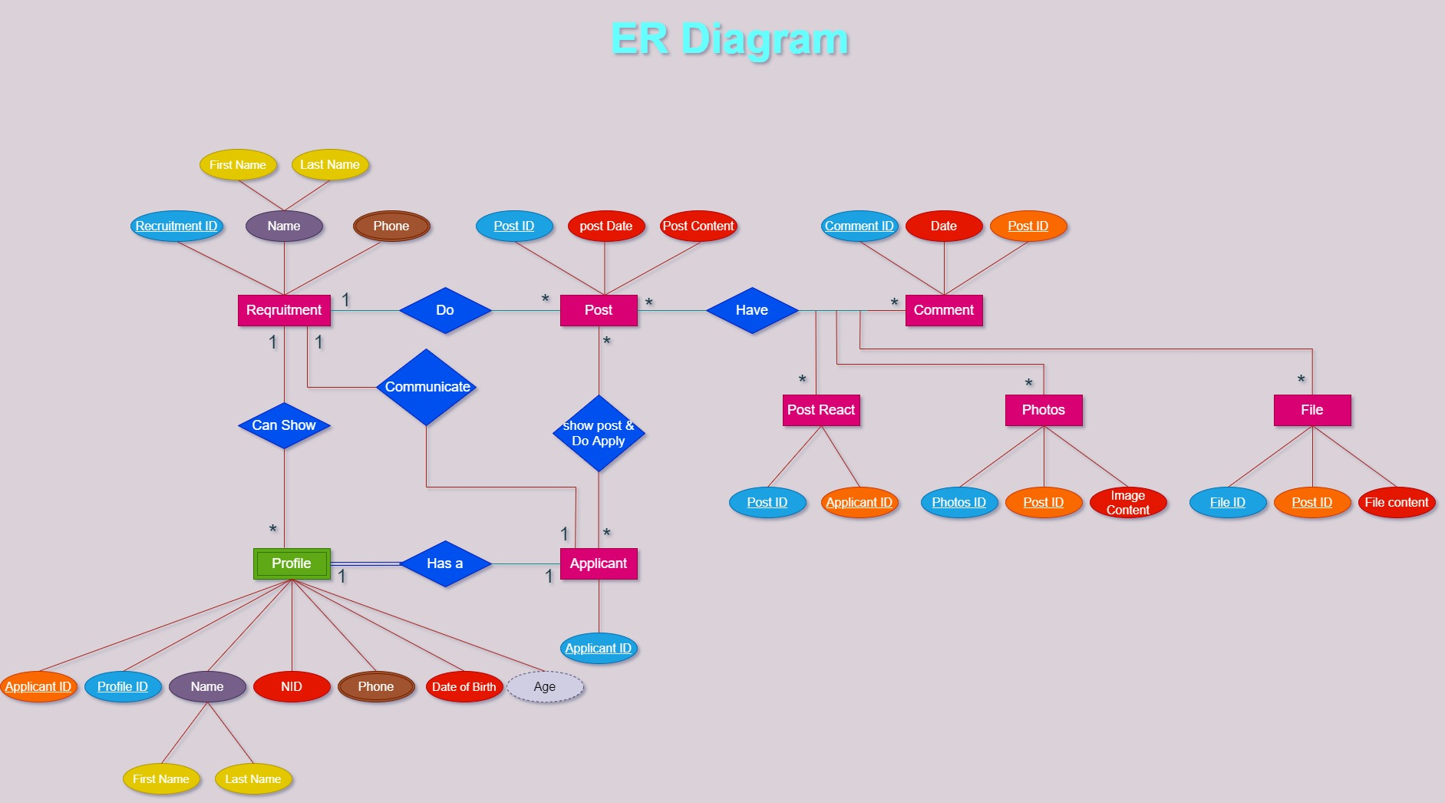

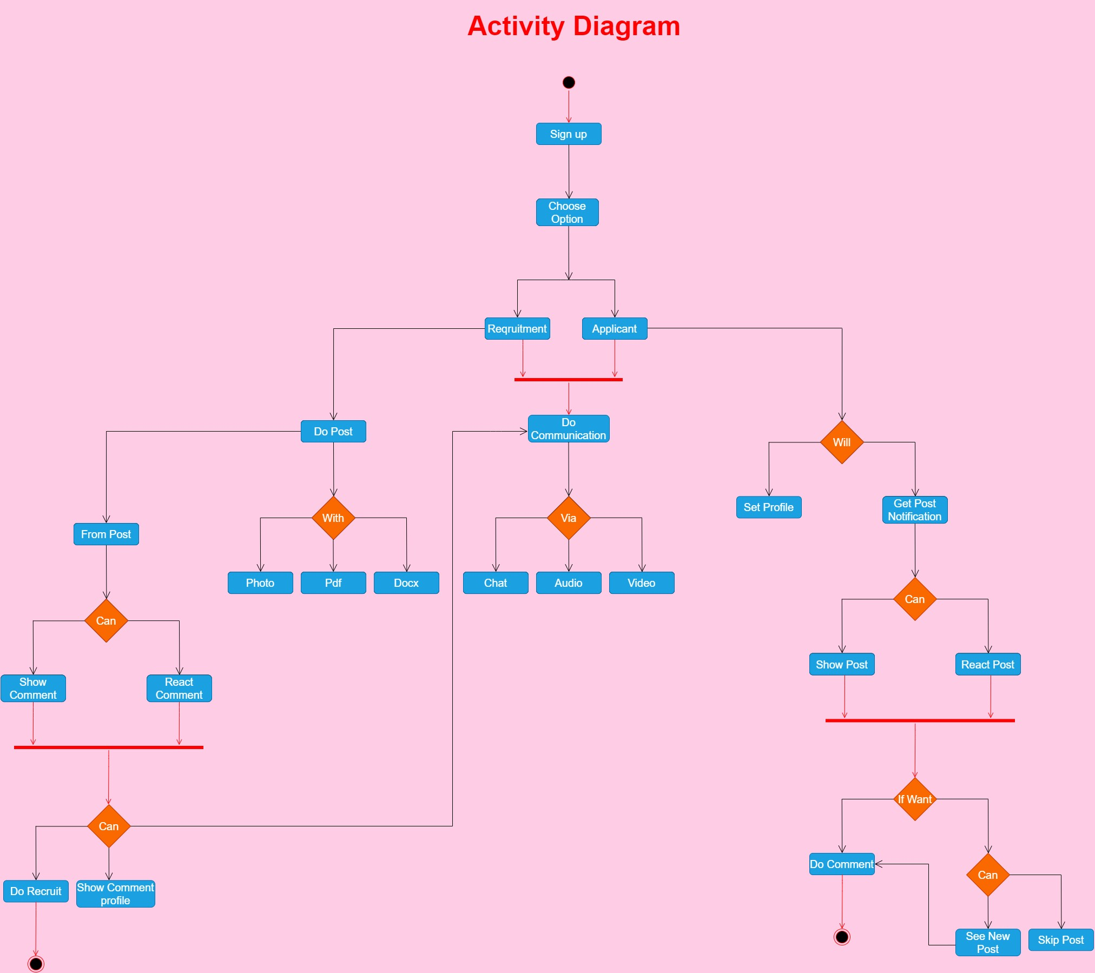

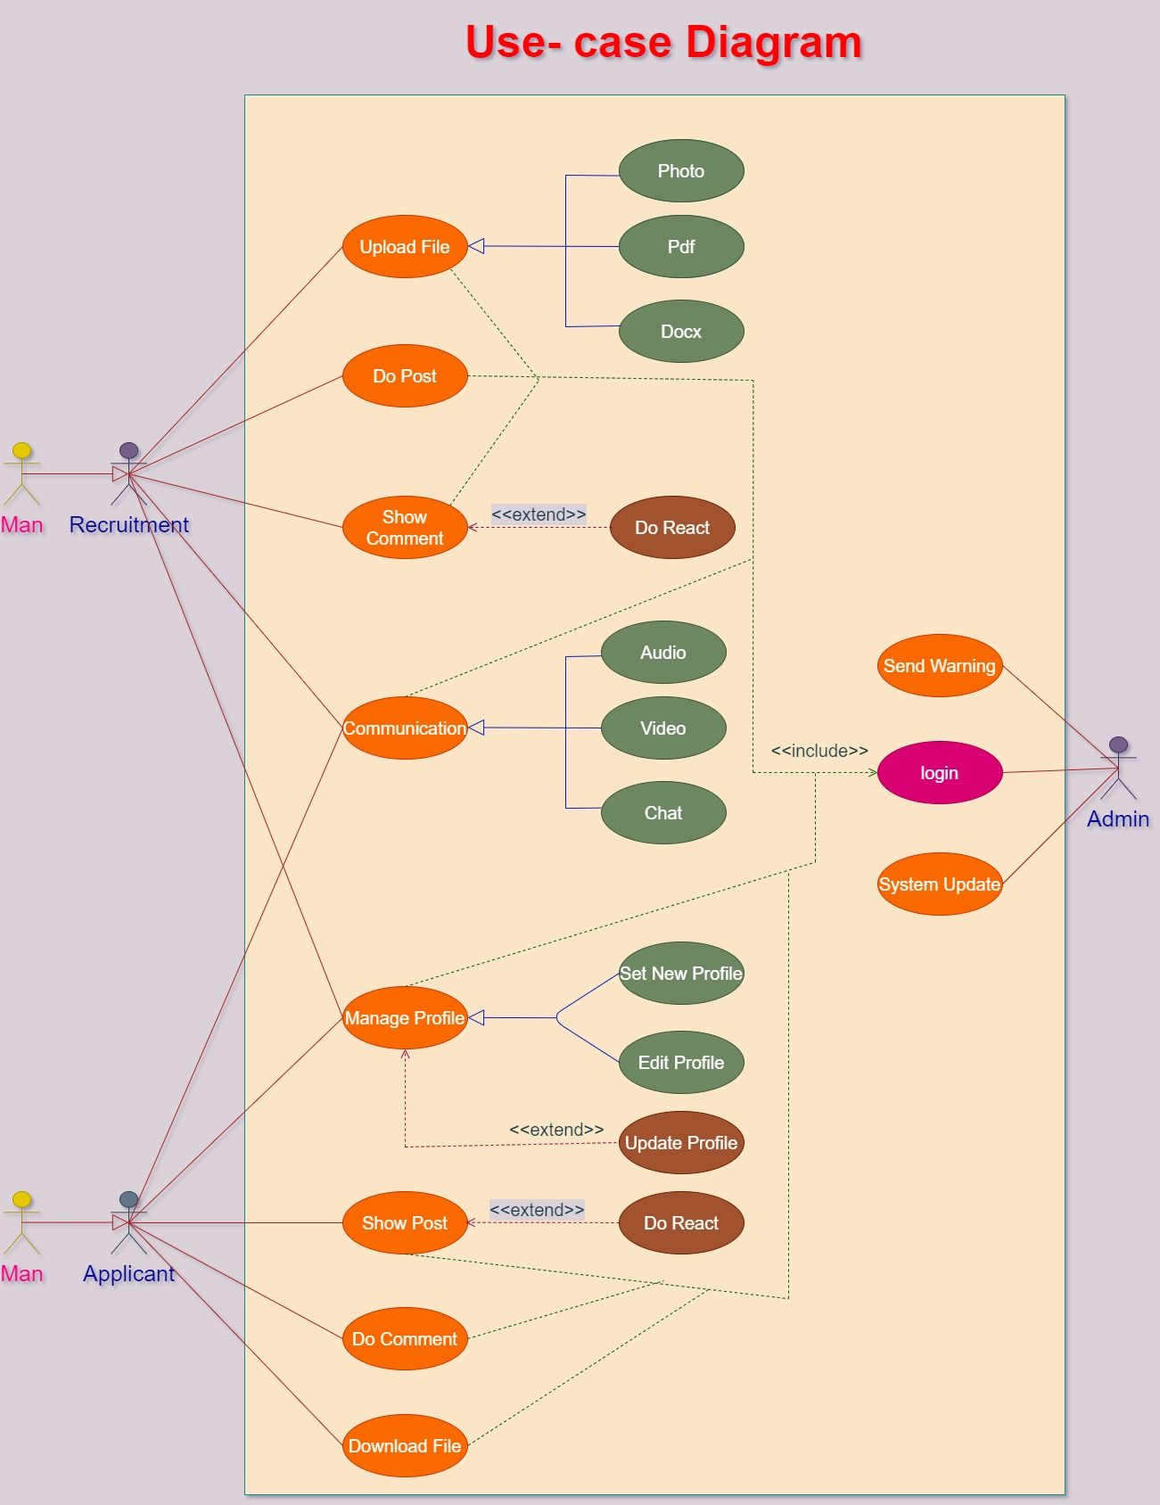

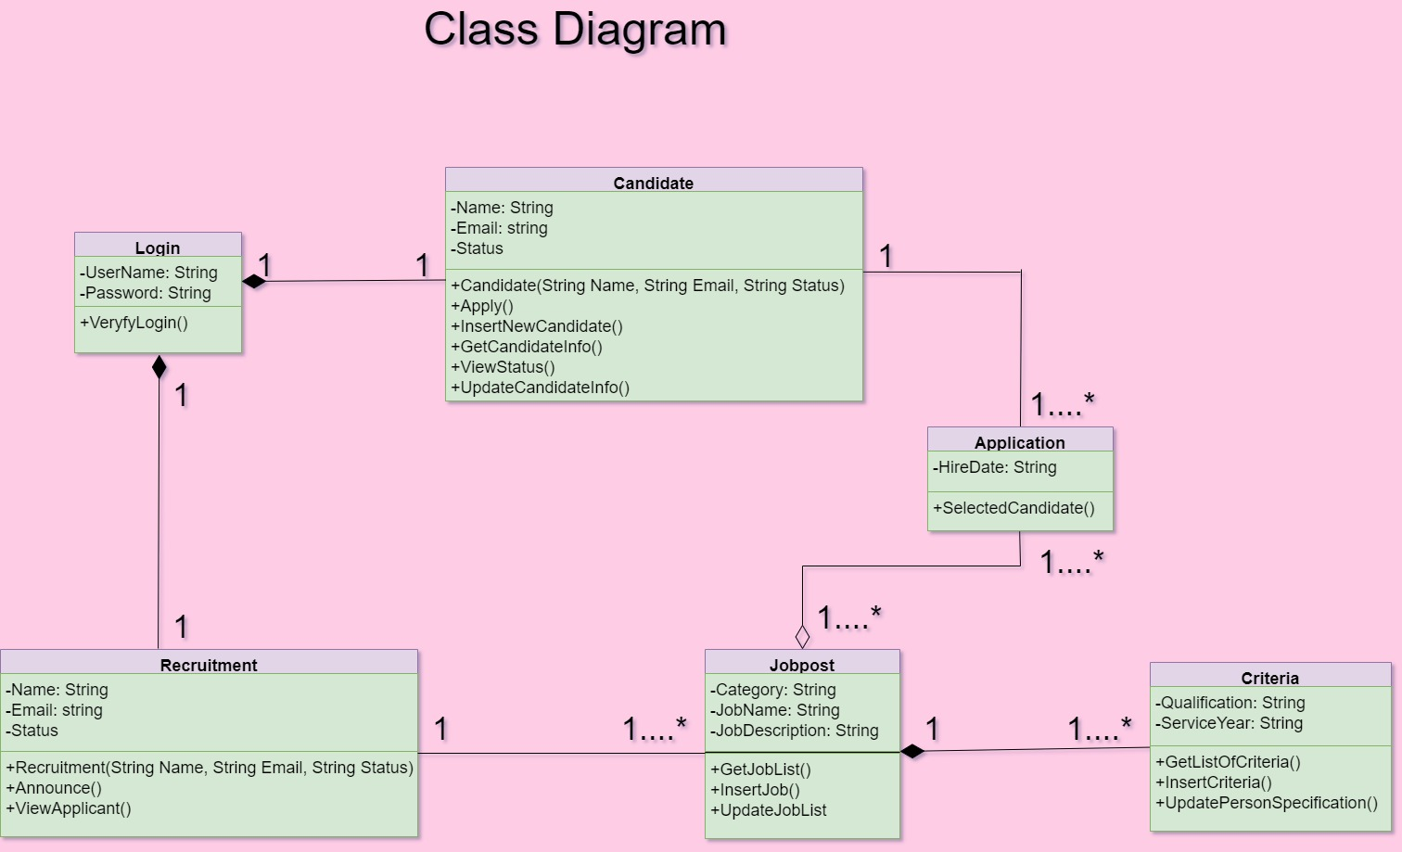

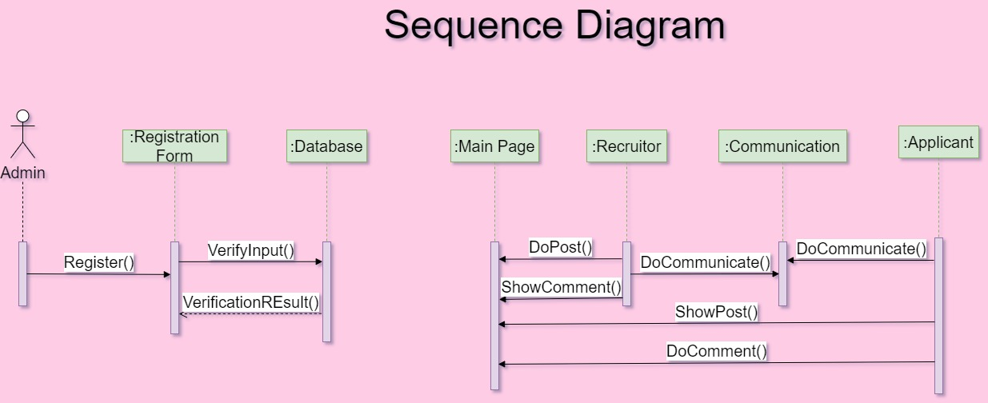

## UI/UX Design:

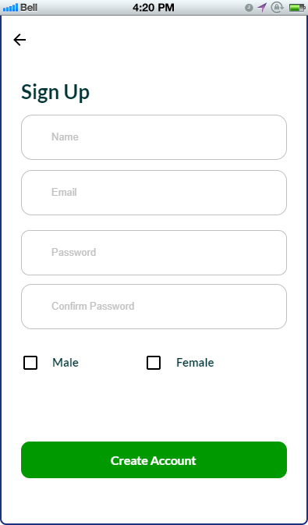

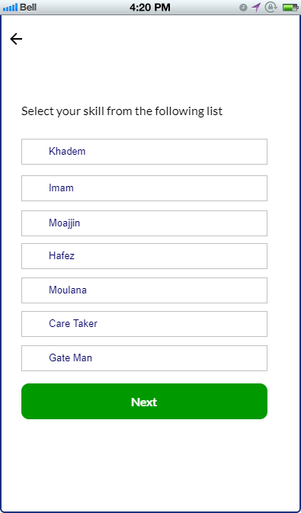

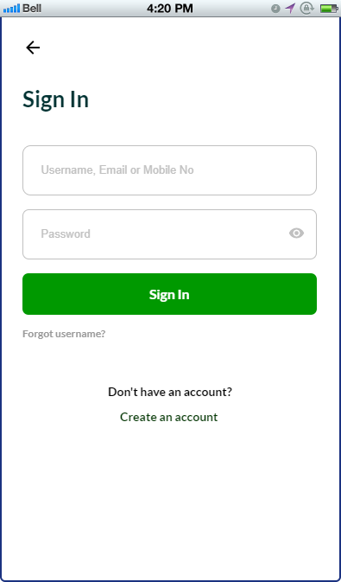

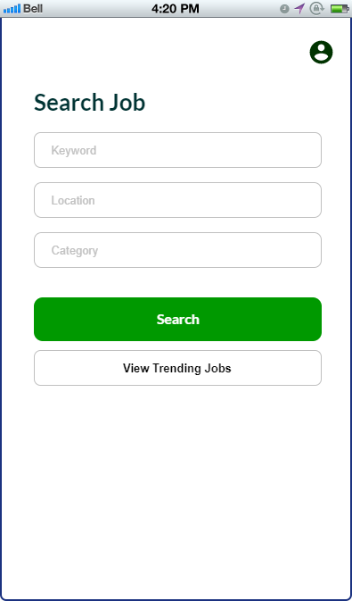

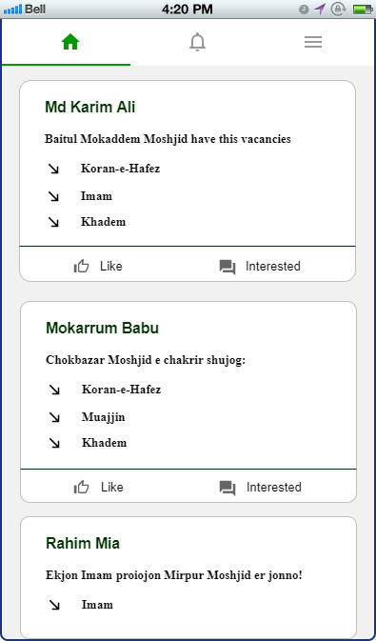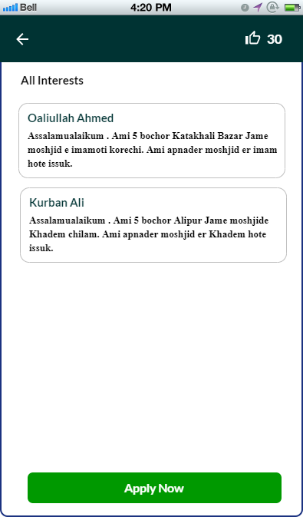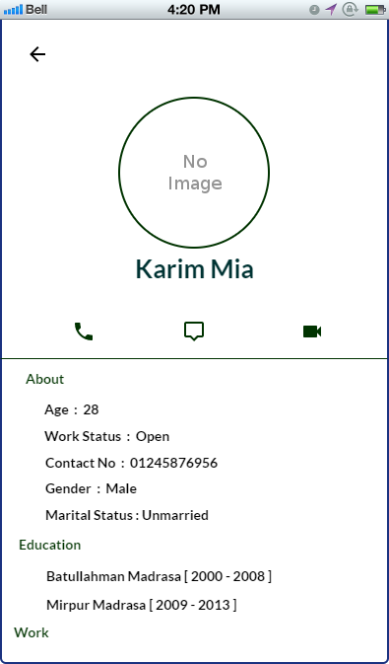

# 6.1 SYSTEM TEST PLAN:

|  |  |  |  |  |  |  |  |  |  |
| --- | --- | --- | --- | --- | --- | --- | --- | --- | --- |
| Project Name: Men of Mosque | | |  |  | Test Designed by: | | | Muhaiminul |  |
|  | |  |  |  |  |  |  |  |  |
| Test Case ID: FR_1 | | |  |  | Test Designed date: April 21, 2021 | | |  |  |
|  | |  | |  |  |  |  |  |  |
| Test Priority (Low, Medium, High): High | | | |  | Test Executed by: | | | Saif |  |
|  | |  |  |  |  |  |  |  |  |
| Module Name: Sign-up Session | | |  |  | Test Execution date: 22 November,2021 | | |  |  |
|  | |  | |  |  |  |  |  |  |
| Test Title: Store user information | | | | | |  |  |  |  |
|  | |  | |  |  |  |  |  |  |
| Description: Test sign-up page | | | |  |  |  |  |  |  |
|  | |  | |  | |  |  |  |  |
| Precondition (If any): User have to select one category | | | | | |  |  |  |  |
|  | |  |  |  | |  |  |  |  |
| Test Steps | |  | Test Data | Expected Results | | Actual |  | Status |  |
|  |  |  |  |  |  | Results |  | (Pass/Fail) |  |
|  |  |  |  |  | |  |  |  |  |
|  | 1.Go to the sign-up page |  | Name-Shahed  Age-21  Address-Dhaka  NID-12345678  Password-321 | Information and password should store in database | |  |  |  |  |
| . | 2.Fill-up information |  |  |  | |  |  |  |  |
|  | 3.Set password |  |  |  |  |  |  |  |  |
|  | 4.Click submit |  |  |  |  |  |  |  |
|  |  |  |  |  |  |  |  |
|  |  |  |  |  |  |  |  |  |  |

Post Condition: User information is validated and successfully sign-up to account. This information are saved in database.

|  |  |  |  |  |  |  |  |  |  |
| --- | --- | --- | --- | --- | --- | --- | --- | --- | --- |
| Project Name: Men of Mosque | | |  |  | Test Designed by: | | | Muhaiminul |  |
|  | |  |  |  |  |  |  |  |  |
| Test Case ID: FR_2 | | |  |  | Test Designed date: April 21, 2021 | | |  |  |
|  | |  | |  |  |  |  |  |  |
| Test Priority (Low, Medium, High): High | | | |  | Test Executed by: | | | Saif |  |
|  | |  |  |  |  |  |  |  |  |
| Module Name: Communication Session | | |  |  | Test Execution date: 22 November,2021 | | |  |  |
|  | |  | |  |  |  |  |  |  |
| Test Title: Do communicate between users | | | | | |  |  |  |  |
|  | |  | |  |  |  |  |  |  |
| Description: Test communication option | | | |  |  |  |  |  |  |
|  | |  | |  | |  |  |  |  |
| Precondition (If any): Null | | | | | |  |  |  |  |
|  | |  |  |  | |  |  |  |  |
| Test Steps | |  | Test Data | Expected Results | | Actual |  | Status |  |
|  |  |  |  |  |  | Results |  | (Pass/Fail) |  |
|  |  |  |  |  | |  |  |  |  |
| 1. | 1.Go to the communication logo |  | Option: Audio, video, chat | User shall successfully communicate via audio, video or chat | |  |  |  |  |
|  | 2.Three communication option |  |  |  | |  |  |  |  |
| 3. | 3.Audio, video, chat |  |  |  |  |  |  |  |  |
| 4. | 4.Click one option |  |  |  |  |  |  |  |
|  |  |  |  |  |  |  |  |
|  |  |  |  |  |  |  |  |  |  |

Post Condition: User is successfully communicate with others. This communication record are save in the database.

|  |  |  |  |  |  |  |  |  |  |
| --- | --- | --- | --- | --- | --- | --- | --- | --- | --- |
| Project Name: Men of Mosque | | |  |  | Test Designed by: | | | Muhaiminul |  |
|  | |  |  |  |  |  |  |  |  |
| Test Case ID: NFR_1 | | |  |  | Test Designed date: April 21, 2021 | | |  |  |
|  | |  | |  |  |  |  |  |  |
| Test Priority (Low, Medium, High): High | | | |  | Test Executed by: | | | Saif |  |
|  | |  |  |  |  |  |  |  |  |
| Module Name: Efficiency | | |  |  | Test Execution date: 22 November,2021 | | |  |  |
|  | |  | |  |  |  |  |  |  |
| Test Title: Prerequisite to this system | | | | | |  |  |  |  |
|  | |  | |  |  |  |  |  |  |
| Description: Test run this software to the user device | | | |  |  |  |  |  |  |
|  | |  | |  | |  |  |  |  |
| Precondition (If any): User must have a well configuration device with sufficient bandwidth | | | | | |  |  |  |  |
|  | |  |  |  | |  |  |  |  |
| Test Steps | |  | Test Data | Expected Results | | Actual |  | Status |  |
|  |  |  |  |  |  | Results |  | (Pass/Fail) |  |
|  |  |  |  |  | |  |  |  |  |
|  | 1.Check Processor capacity |  | Processor capacity: 3.5%  Memory: 50MB  Bandwidth: 512 Kbps | The system should easily run to the user device | |  |  |  |  |
|  | 2.Check memory  3.Check communication bandwidth |  |  |  | |  |  |  |  |
|  |  |  |  |  |  |  |  |  |  |
| 4. |  |  |  |  |  |  |  |  |
|  |  |  |  |  |  |  |  |
|  |  |  |  |  |  |  |  |  |  |

Post Condition: The system is running successfully on the user’s device.

|  |  |  |  |  |  |  |  |  |  |
| --- | --- | --- | --- | --- | --- | --- | --- | --- | --- |
| Project Name: Men of Mosque | | |  |  | Test Designed by: | | | Muhaiminul |  |
|  | |  |  |  |  |  |  |  |  |
| Test Case ID: NFR_2 | | |  |  | Test Designed date: April 21, 2021 | | |  |  |
|  | |  | |  |  |  |  |  |  |
| Test Priority (Low, Medium, High): Medium | | | |  | Test Executed by: | | | Saif |  |
|  | |  |  |  |  |  |  |  |  |
| Module Name: Usability | | |  |  | Test Execution date: 22 November,2021 | | |  |  |
|  | |  | |  |  |  |  |  |  |
| Test Title: User experience | | | | | |  |  |  |  |
|  | |  | |  |  |  |  |  |  |
| Description: Test user friendliness of this system | | | |  |  |  |  |  |  |
|  | |  | |  | |  |  |  |  |
| Precondition (If any): Null | | | | | |  |  |  |  |
|  | |  |  |  | |  |  |  |  |
| Test Steps | |  | Test Data | Expected Results | | Actual |  | Status |  |
|  |  |  |  |  |  | Results |  | (Pass/Fail) |  |
|  |  |  |  |  | |  |  |  |  |
|  | 1.Check upload time |  | Upload time: 15sec  Comment Visibility: 2sec  System open time: 3sec | The system shall able to maintain the test data time | |  |  |  |  |
|  | 2.Check comment visibility  3.Check system open time |  |  |  | |  |  |  |  |
|  |  |  |  |  |  |  |  |  |  |
| 4. |  |  |  |  |  |  |  |  |
|  |  |  |  |  |  |  |  |
|  |  |  |  |  |  |  |  |  |  |

Post Condition: User experience of this system is user friendliness.